MultiThreshold Manual

Ray Meddis,
Department of Psychology, University of Essex,
Colchester, UK. CO7 9SW, rmeddis@essex.ac.uk

This software is shared on the understanding that the recipient accepts full responsibility for how it is used and agrees not to redistribute it in any form. The author makes no guarantees of any kind by sharing this software. If you know someone who wants a copy, please refer them to the author who will send them the latest version of the software. Otherwise, old versions circulate to the detriment of our reputation!

Introduction.
MultiThreshold is a software tool for measuring a range of clinically relevant psychophysical thresholds quickly and painlessly. It has been designed around research activities in the Essex Hearing Laboratory using volunteers with a range of different hearing impairments. The software is flexible and to avoid confusion it is strongly recommended that you read this manual sequentially and avoid ‘trying out all the options’ at the outset.

MultiThreshold is part of a much larger package (MAP1_9) that includes auditory modelling software. The MultiThreshold program has been designed so that it can evaluate computer models of patient hearing as well as measuring the patient’s hearing itself. The use of computer modelling is not explained in this manual.

The software requires a MATLAB application (7.0 or later) and should work with any 24-bit sound card. It is assumed that the computer setup has two monitors, one for the experimenter and one for a patient in the sound-proof booth. It will work with only one monitor but two is best. The listener in the booth should have control of a mouse. A Cedrus button box can also be used (optionally) to record responses. If a Cedrus box is present, the software will recognize it automatically.

Getting started
The software uses two graphical user interfaces (GUIs); one for the experimenter (expGUI_MT) and one for the subject (subjGUI_MT.m). To run the program:
- Open MATLAB,
- Navigate to the folder ‘MAP1_14\multithreshold 1.46’
- Run ‘expGUI_MT’
- you should see the experimenter GUI (Fig. 1A)
- To start measuring a threshold:
  - type the patient’s name into the ‘name’ window (top centre)
  - click on the ‘run’ button.
- This will now generate a second GUI for the patient: (Fig. 1B).

A B
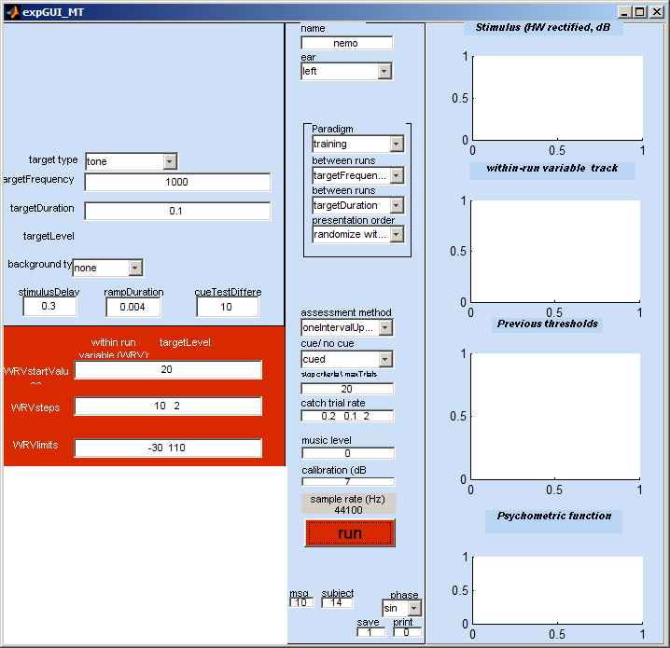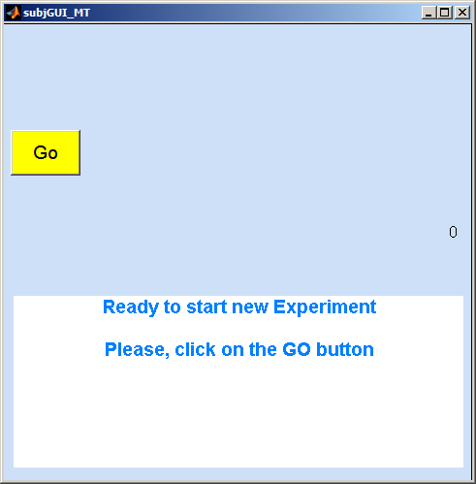
Figure 1. A: Experimenter GUI. B: subject/patient GUI.

The patient GUI will appear on the experimenter’s monitor. Drag this onto the patient’s own monitor if you have a two-screen system.

By default the program is set up to make a simple pure-tone threshold measurement at 1 kHz using a 100-ms tone burst stimulus. We shall use this to illustrate the way things work.

The subject should be wearing headphones that are connected to the sound card of the computer. He initiates the measurements by clicking on the ‘Go’ button. One or two tones will be played approx 1 s after hitting the button, and the subject GUI will change and should look like Fig. 2.
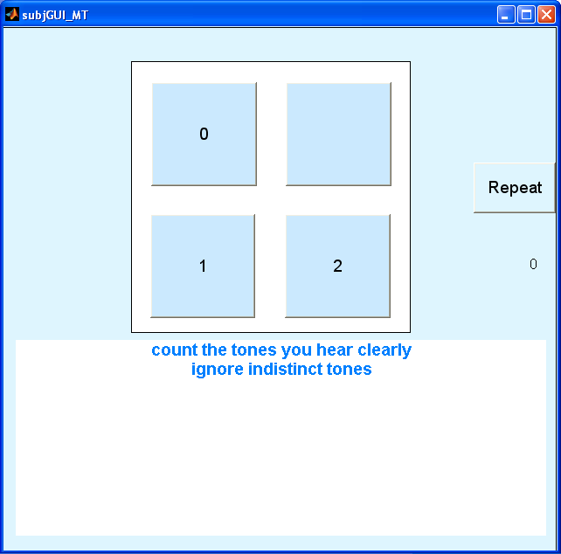
Figure 2. Patient GUI waiting for patient’s response.

The subject should then decide how many tones he hears and click on the appropriate button.

The next stimulus will be presented soon after and the series will continue until the threshold measurement is complete.

The subject will hear a ‘tada!’ sound when the run is at an end and the measurement is complete.

Stopping. If, for any reason the experimenter wants to restart the experiment prematurely, he can do so by clicking on the ‘run’ button again. This resets everything and all previous data from the previous run(s) are abandoned.

At the end of the measurement, summary information will be printed in the MATLAB console window. A great deal of information about the measurement procedure is printed. In fact every variable and all results related to the measurement are printed out. Much of this can be ignored in everyday use but it can be useful for diagnostic purposes and can be vital when evaluating data retrospectively because it is a complete account of what was done. The most important information is printed at the beginning.

At the head of the printout, you will find something like this:

******** multithreshold version 1.46

Name: Meddis
paradigm: training
Ear: left
method: oneIntervalUpDown/ withCue
date: 10-Sep-2011 07_43_51

thresholds
targetFrequency/ targetDuration
0.1
1000 21.4713

Experimenter GUI (introduction)
The experimenter graphical user interface (GUI) can be used to set up the stimulus paradigm. It also displays progress through the testing procedure
Stimulus | Paradigm
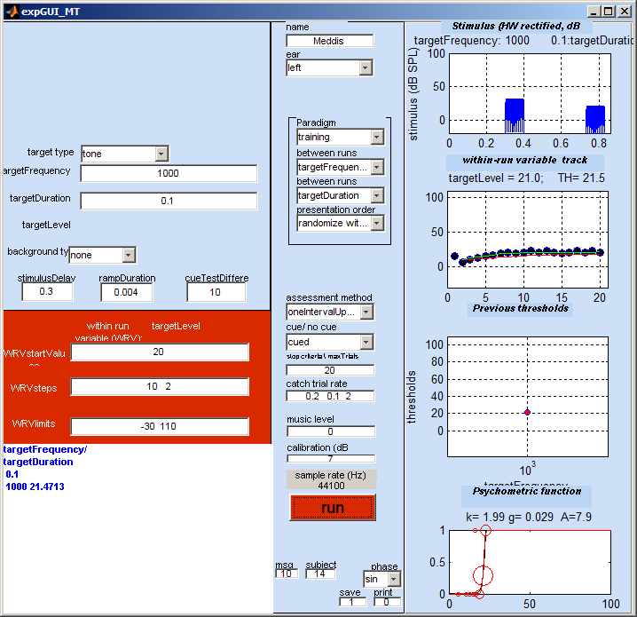 |  |  | Figure 1: current stimulus
 |  |  | Figure 2: levels track
 |  |  | Figure 3: previous thresholds
 |  |  | Figure 4: psychometric function
Figure 3. Experimenter GUI at the end of a threshold measurement.

Stimulus parameters (left vertical panel)
The boxes to the left of the screen allow the user to change the stimulus parameters. The quantities in the boxes are in Hz, seconds or dB SPL. The visibility of these parameter windows depends of the testing paradigm in use. For example, the ‘training’ paradigm described above only allows for the target frequency and target duration parameters to be changed.

For simplicity, the description immediately below refers only to ‘single-interval’ (yes/no) threshold estimation procedures. Two-alternative, forced-choice parameters are described later.

Within-runs variable (WRV)
In any test run, there is one stimulus parameter that changes from trial to trial. This is called the within runs variable. In the case of absolute threshold measurements, the WRV is, obviously, the level of the target tone. The parameters in the red boxes set the start value, step size and the limits of variation of this parameter.

The WRVstartValues box indicates the starting level of the stimulus.

The WRVsteps box controls the step sizes. When the patient reports having detected the stimulus, the level of the stimulus will be raised, if not it will be lowered. The amount by which it is raised or lowered is given in the WRVsteps box. The default values are ’10 2’. This means that the level will be changed in steps of 10 dB until the patient first changes his judgment from ‘yes’ to ‘no’ or vice-versa. After this ‘first reversal’ the level is set to the midpoint of the last ‘yes’ and ‘no’ responses. The procedure then continues with a reduced steps size of 2 dB.

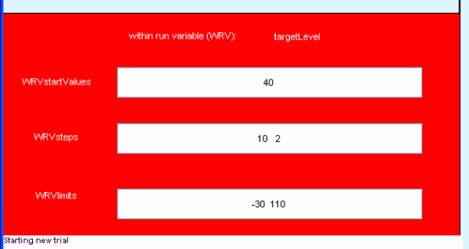
Figure 4. Within run variable (WRV) panel.
The WRVlimits box specifies the range of levels to be allowed. If the level moves outside of these limits, the program will abort this run and specify the threshold as ‘NaN’ (not a number in MATLAB speak).

The unchanging characteristics of the stimulus are set in the boxes at the top of the stimulus panel. Here are some examples.

stimulusDelay. The stimulusDelay specifies the delay before either the stimulus is played. It is useful for a number of reasons. It specifies approximately the time between the subject’s response and the onset of the stimulus. It also specifies the time between the cue stimulus and the test stimulus when a cued paradigm is in use. Finally, it is useful in conditions when a background noise is played. In this case the background noise starts immediately after the user response and the stimulus delay specifies the delay between the onset of the noise and the onset of the stimulus.
rampDuration. The rampDuration box refers to the duration of a ‘raised cosine’ ramp applied to all stimulus components (backgrounds, maskers and targets). The ramps are included in the duration of the stimulus; i.e. a ‘target duration’ or ‘masker duration’ defines the time from the beginning of the onset ramp to the end of the offset ramp.
cueTestDifference. When a cue is used, this window becomes visible. It sets the difference in level between the cue target and the test target so as to make target detection easier in the cue condition. For example, when measuring absolute threshold, the cueTestDifference is the difference in level between the cue and the target tones. In the TMC or IFMC paradigms (see below), this difference would be applied to the masker.

Background
By default, the background is silence. However, other backgrounds are available (e.g. white noise, pink noise, babble). When one of these is selected a box appears allowing the level of the background to be set. The background plays throughout the stimulus from immediately after the subject’s response.

Paradigm settings (middle vertical panel)
The middle panel is used to set up the design characteristics of the measurements procedure.
Note that some menus disappear from the screen when they are not relevant to a particular condition.

Name
The name is used when recording the results to file

Ear
The second pop up menu in the central panel selects the ear to be tested. In addition to left and right it is possible to select diotic presentation.

A dichotic option also exists but only applies to masking experiments (see below) where the target is presented to the chosen ear (e.g. targetLeft) and the masker is presented to the contralateral ear.

The other options are related to modelling work and are not explained in this manual.

Paradigm
There are four pop-up menus (grouped together) used to define the kind of experiment required. These are described in more detail below.

The first menu (Paradigm) is the most useful. You can select a paradigm and the software will put appropriate values in all the boxes on the GUI for you. For regular testing, most users will often only be required to choose a paradigm from the list and then hit the run button.

For clinical use, the paradigms of most interest are ‘training’, ‘absThreshold’, ‘TMC’ (for assessing compression) and ‘IFMC’ (for assesseing frequency selectivity). Other paradigms are intended for laboratory testing and for evaluation of computer models of hearing.

When a paradigm is selected, all of the boxes on the GUI are re- filled with new values that are the default parameters for that paradigm. It is possible to create your own paradigms that automatically fill the boxes with values that you prefer. This facility is explained later.

Three other boxes are grouped with paradigm. These are mainly concerned with the control of the testing session as a whole and the order of presentation of different frequencies, durations, etc. If you are using a standard paradigm, these can be ignored for the present but are explained later.

Assessment method
Various assessment methods are available (single interval up/down, maximum likelihood, 2AFC++, 2AFC+++) and these are explained below. For patient testing, we recommend the ‘single interval up/down’ method. The other options have more use in a laboratory setting.

Stop criteria \ max trials
Each stimulus presentation is called a ‘trial’. A run continues for a fixed number of trials after the first reversal. The value in this box sets the number of trials after the first reversal. The default value is set to 20 although in practice it will often be found that 10 trials give just as good a result.

Catch Trials
A fraction of the trials are ‘catch trials’. During a catch trial, no stimulus is presented. If the patient responds ‘yes’ on a catch trial, the run is aborted and the patient must click on ‘Go’ to restart the run. (This does not apply to laboratory AFC procedures)

Patients should be instructed only to respond ‘yes’ only when they are sure that they have heard the tone. We have experienced no difficulty with this conservative approach when using patients and long error-free runs are normal.

The catch trial rate is set by a trio of values in the ‘catch trial rate’ box. It may never be necessary to change this and the following is for information only. At the beginning of a run, the catch trial rate is the first number in the box. This is normally 0.2 and represents a 20% catch trial rate. If the patient is caught out, the rate is increased on the next run. An increase is in steps of 0.1 up to a maximum of 0.5. If he is not caught out on a run, it is reduced progressively to a minimum rate specified by the second value in the box (normally 0.1). The final value of the trio should be ignored for the present as it be removed in future issues of the software.

Catch trials never occur on the first trial of a run. Catch trials always occur on the second trial of a run. After that, they are distributed at random with no constraints.

Music level
This value is used to increase or decrease the level of the musical signatures that indicate when a run or session is completed (‘tada!’). a default value of ‘0’ is adequate for listeners with normal hearing but may need to be increased for some patients.

Calibration
An attenuation of the output signal can be applied using the ‘calibration (dB attenuation)’ box. Ideally, your equipment should be set up so that an attenuation of 0 dB is appropriate.

The program computes the signal as an integer vector specified in microPascals. This is the numeric value that is sent to the sound card. The calibration works by reducing the value sent to the sound card and therefore, necessarily reduces the dynamic range of the signal. Negative calibration values can also be used. If a negative calibration value is used, this boosts the signal but the dynamic range is still reduced because the highest values cause the sound card to ‘clip’.

Sample rate
The stimulus sample rate is fixed (by the software) at 100000 Hz and displayed on the experimenter GUI. The sample rate cannot be adjusted using the GUI but must be set in the software.

Run button
Change the parameters and hit ‘run’ to restart the measurements with the new parameters. You can hit ‘run’ at any time. It should abort the current run (if any) and start with the current set of parameters.

Stop button
This is visible only during model evaluations and can be used to stop the run. The program stops before the beginning of the next trial; so a short wait may be involved.

Results panel
The top right panel shows a graphical representation of the most recent stimulus (half-wave rectified and plotted on a vertical log scale). This changes from trial to trial and allows the experimenter to see what is happening.

The second panel shows the sequence of the stimulus levels presented so far to the subject. The red line shows the running estimate of the threshold.

The third panel should be ignored. Its use is only for development purposes.

The fourth panel shows all previous threshold estimates since hitting the <run> button.

In the fifth panel the red line is the best-fit (logistic) psychometric function to the data on this run. The small dots at the top and the bottom of the graph represent ‘yes’ (1) and ‘no’ (0) responses. The circles represent the proportion of ‘yes’ responses in a single 1-dB wide histogram bin. The size of the circle represents the proportion of responses included in the calculation. If a black line is also shown, this is the fit of a rival (‘rare event’) function of local interest to Essex Researchers.

Message panel
A white panel to the bottom-left of the experimenter GUI displays all of the subject responses, levels and threshold estimates in the current run.

Row 1: the subject response (1=detected, 0 = not detected).
Row 2: the corresponding level of the stimulus
Row 3: the current estimate of the threshold.

Other messages might be displayed here including warnings and reports of illegal parameter specifications.

At the end of a run, this information is replaced by a summary of the thresholds obtained.

Setting up an experiment
Every experiment is different and many parameters need to be established at the beginning of each session. MultiThreshold takes some of the labour out of this by setting default parameters for a range of stimulus paradigms. The first step in setting up an experiment should involve the selection of a paradigm from the paradigm pup-up menu in the central panel. This will automatically change all parameters to a reasonable starting value. These can then be changed to suit individual needs before beginning a session. The characteristics of each paradigm are described later.

Terminology:
A ‘session’ consists of a series of ‘runs’. Each run produces a threshold estimate.
A’ run’ consists of a series of ‘trials’.
Each ’trial’ is associated with a decision by the subject. After each trial, the user decision is posted in the message panel at the bottom left of the experimenter GUI.
At the end of each run, the threshold is added to the plot of previous estimates in panel 4 on the experimenter GUI.
At the end of each session a summary report of all thresholds is shown in the message window and a complete report is printed in the command window. The data for that session is also saved in the ‘savedData’ folder under a unique filename.
Within a run, one variable (e.g. target level) is varied from trial to trial. This is called the ‘within-runs variable’ (WRV).
Between runs, other variables may change (e.g. masker level in a forward masking experiment). These variables are called ‘between-runs variables’. Normally, there is only one between-runs variable but the system does allow for the possibility of two. These variables are identified in the two popup panels immediately below the paradigm popup menu. Sometimes these are specified even though they are apparently not used. This is because they are used to define displays and printouts elsewhere in the program. Normally, the user should ignore these menus as they are set automatically and appropriately when the paradigm is selected. They can be useful, however, for certain advanced applications.

Multiple runs in one session
A single threshold measurement is called a ‘run’. Multiple runs are possible and, indeed, normal with MultiThreshold. To illustrate this process, select the ‘absolute threshold’ paradigm from the ‘Paradigm’ pop up menu in the central panel. The targetFrequency box will now contain a number of different frequency values:

250 500 1000 2000 4000 8000

Clicking on the ‘run’ button will now initiate 7 threshold measurements in sequence. At the end of each measurement, the patient will be invited to click on the ‘Go’ button to initiate the next run.

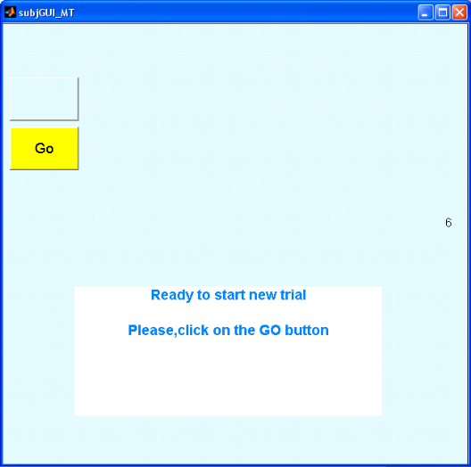
Figure 5. Subject GUI waiting to initiate a second run.
The summary report looks like this:

******** multithreshold version 1.29
Name: Ray Meddis
Ear: left
date: 09-Apr-2008 07_28_09
paradigm: absThreshold

thresholds
targetFrequency/ targetDuration
0.5
250 15.8862
500 8.1767
1000 8.2452
1001 6.9469
2000 4.0175
4000 13.3904
8000 12.0761

Between-runs variables
Under the paradigm popup menu, two other popup menus identify two ‘between-runs variables’. These are set automatically when the paradigm is chosen but it is useful to understand how the program is controlling the sequence. The first between-runs variable identifies which parameter will change between runs. In this case it is targetFrequency. A second between-runs variable is also selected (targetDuration). This allows us to set multiple values of target duration as well. On this occasion only one value of targetDuration was specified but more than one duration could have been specified.

When two between runs variables are specified, the second set of values will be changed more slowly. For example, we might choose to use two durations 0.008 and 0.5 s. In this is the case, all measurements at 0.008 s will be made before those at 0.5 s. If both variables are used in this way, the final report will look like this.

******** multithreshold version 1.29
Name: Meddis
Ear: left
date: 09-Apr-2008 07_38_51
paradigm: absThreshold

thresholds
targetFrequency/ targetDuration
0.008 0.5
250 39.3717 17.2477
500 26.0641 9.6303
1000 23.3528 6.86
1001 22.357 9.173
2000 19.3514 4.5804
4000 21.7742 10.7419
8000 29.5017 12.6421

The thresholds for the short duration target are in the second column and those for the long duration are in the end column. Note that all rows and columns are sorted into numerical order and do not represent the actual sequence of the trials.

Presentation order
The order of presentation of the runs can be fixed or randomized. Use the ‘presentation order’ popup menu to select an option.

The ‘fixed sequence’ option follows the order prescribed in the relevant stimulus parameter boxes; the second between-runs variable is the most slowly changing.

The ‘randomize within blocks’ option varies the second between-runs variable slowly in a fixed sequence but randomizes the sequence of the first between-runs variable.

The ‘randomize across blocks’ option presents the whole sequence in a random order.

Putting multiple values in a parameter box is a mistake and will cause an abort unless that parameter has been selected as a between-runs variable using one of the two pop-up menus.

Assessment method
The popup menu ‘assessment method’ can be used to select different methods for measuring thresholds. The ‘oneIntervalUpDown’ method is the default and is the simplest and is used here in the introduction. The others (maximum likelihood and 2AFC) will be explained later if I ever get to the end of writing this manual.
At the end of a run, the threshold is assessed as the mean of the best-fit psychometric function based on the stimulus levels presented after the first reversal. More precisely, the threshold is our best estimate of the level at which the subject detects the stimulus on 50% of occasions. Note that this assumes that the probability of detection rises monotonically across level.

Cued single-interval procedure
This option can be selected using the ‘cue/no cue’ menu. The cued condition is the same as the uncued condition (described above) apart from the introduction of the cue sound. The cued condition is the default and is recommended for general use.

The cue sound is presented immediately before the target and is always identical to the target except that it is adjusted to be easier to hear than the target. For example, when making absolute threshold measurements, the cue is adjusted to be more intense than the target. When the target is above threshold, the patient will hear two tones (the cue tone and the target tone). When the target is just below threshold, the patient will hear only the cue tone. The patient is asked to specify whether he hears 0, 1 or 2 tones (Fig. 6).
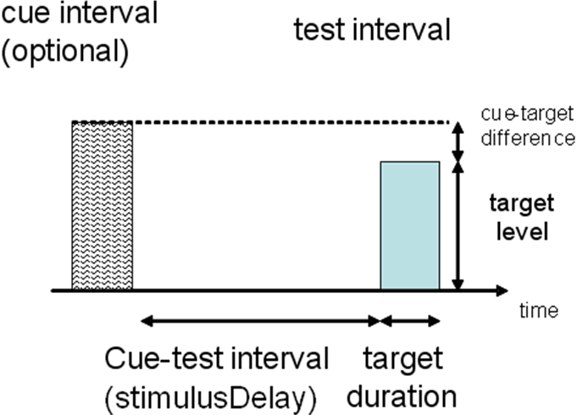
Figure 6. Stimulus schematic for a cued single-interval procedure in an pure-tone threshold measurement. The target is the blue box on the right. The cue is the grey box on the left. It is more intense and easier to hear. The subject is asked to count how many tones he hears.

The patient is judged to have heard the target only when he makes a ‘2’ response.

The intensity difference between the cue and the target can be set in the ‘cueTestDifference’ box that appears when the cued condition is selected.

The time interval between the end of the cue and the beginning of the target is set in the stimulusDelay box.

A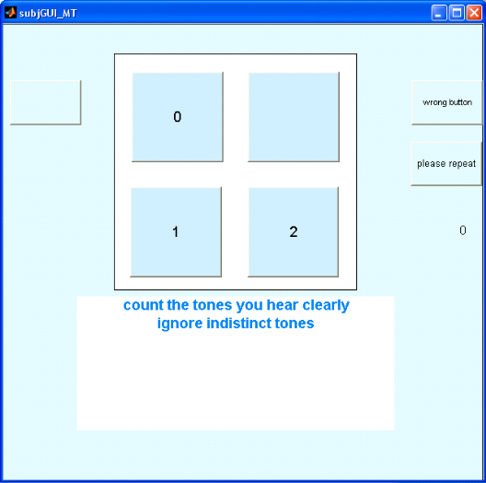 B 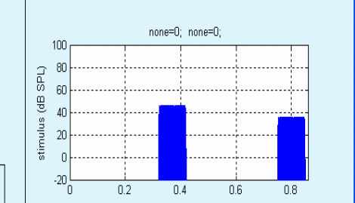
Figure 7. A: subject GUI for the cued condition. The subject is asked to count how many tones he hears. B: Cue and target as they appear on the experimenter GUI; the target is the second (and less intense) sound.

To avoid confusion, remember that the cue is just a cue. It is not part of the test; only a warning that the target is about to be presented. Do not confuse this with 2AFC where the subject has to choose one of two intervals.

The cue has the same characteristics as the stimulus in order to act as a reminder of what he is listening for. This is effective in keeping thresholds as low as possible.

The subject is deemed to have heard the target only when he reports hearing ‘2’ tones because the cue is always more audible that the target.

Masked thresholds
Thresholds for a target can be measured in the presence of a masking stimulus. The simplest example is forward masking.

Example: forward masking paradigm. To illustrate this select the ‘forwardMasking’ option from the ‘Paradigm’ menu. The experimenterGUI will display more boxes to allow the masker characteristics to be specified. The top right panel shows the first stimulus presented to the subject. This is a long masker stimulus followed by a gap and then a short target stimulus.

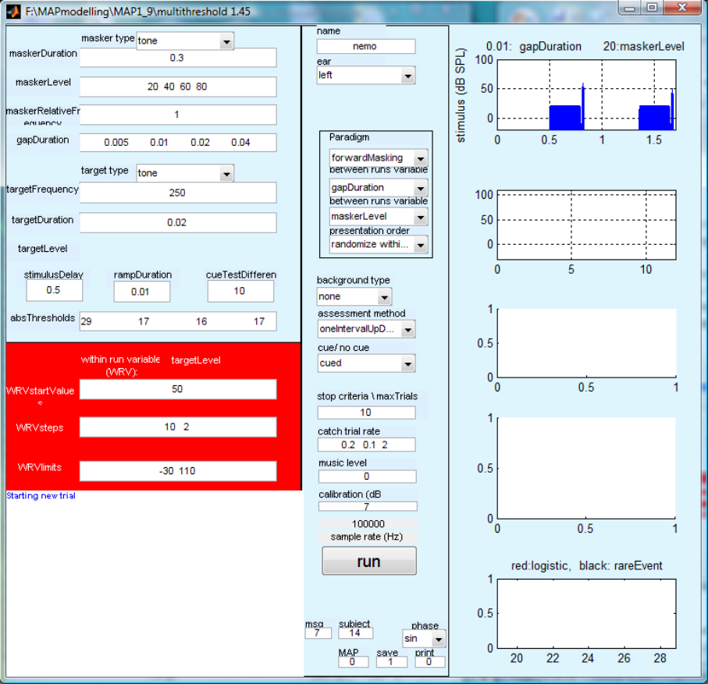

Figure 8. Experimenter GUI for forward masking paradigm

The masker can be either a tone or broadband noise and this is selected in the masker type pop-up menu. Its duration is specified in the maskerDuration box.

The masker duration includes ramps (i.e. is measured from the beginning of the onset ramp to the end of the offset ramp). The masker is given the same duration ramps as the target and the duration of the ramp is specified in the rampDuration box.

The masker level is specified in the maskerLevel box. Masker level is a between-runs variable for this paradigm (see the ‘between run variable (1)’ menu). As a consequence, multiple values for masker level can be specified.

Masker frequency is specified in the maskerFrequency box. This is specified as relative frequency, i.e. relative to the target frequency. If the relative frequency is 1 the masker frequency is automatically set to the same frequency as the target. If the masker relative frequency is set to 2 its frequency is set one octave above the target. It is important not to specify this as a frequency in Hz.

The gap duration specifies the time from the end of the masker to the beginning of the target. In the ‘forward-masking’ paradigm, the gap duration is selected as a between run variable and this allows a number of gaps durations to be explored.

Negative gap durations. Gap duration can be negative. When a negative gap is set, the target begins before the end of the masker (i.e. simultaneous masking). An extremely long negative gap can be used to place the target before the beginning of the masker to study backward masking.

The patient now hears two stimuli and is asked to count how many have a ‘trailing click’. When the target is above threshold, the patient should hear two tones with trailing clicks. When it is just below threshold, he will hear only one tone with trailing click. If it is well below threshold, he will hear no tones with trailing clicks.Otherwise, the procedure is the same as for absolute threshold measurements.

******** multithreshold version 1.29

Name: MAPmodel
Ear: MAPmodel
date: 09-Apr-2008 07_58_46
paradigm: forwardMasking

thresholds
gapDuration/ maskerLevel
20 40 60 80
0.005 24.0151 25.9095 29.6342 29.1739
0.01 20.7767 25.3551 29.1702 28.1706
0.02 25.2335 28.2915 24.3759 26.1593
0.04 23.4496 22.0837 29.8309 30.1311

Subject preparation
This is a more difficult task than the absolute threshold task. Subjects have to ignore the leading (masking) tone and listen for the click at the end. If the subject is properly prepared he will find the task simple. We regularly run this test with elderly people with no difficulty. Interestingly, people with a hearing impairment find this task easier than people who have normal hearing.

The subject can be prepared by running a few training trials where the gap duration is long (say 0.050 s). Begin the run with a very low starting level for the masker so that only two clicks are heard (cue and target clicks). The program will then increase the level of the masker. Explain beforehand that this will happen and say that the new masking tones must be ignored and only the clicks counted.

The program will automatically present some catch trials where the target click is not present. These check that the subject is doing the task correctly. However, they also provide 20% of trials where the subject can clearly hear how a ‘missing target’ sounds.

It is important to remember that this is still a ‘single interval’ paradigm. The cue is nothing more than a cue to warn the subject that the second stimulus is coming and to remind him of what an audible click sounds like. This approach should not be confused with a two-interval forced-choice paradigm where the patient is asked to choose between the two stimuli. Here, we are only concerned to know whether the patient has heard the target tone pip. When the patient clicks on the ‘2’ button, this is taken as evidence that he has heard it.

The time interval between the end of the cue stimulus and the beginning of the test stimulus is set in the stimulusDelay box.
A 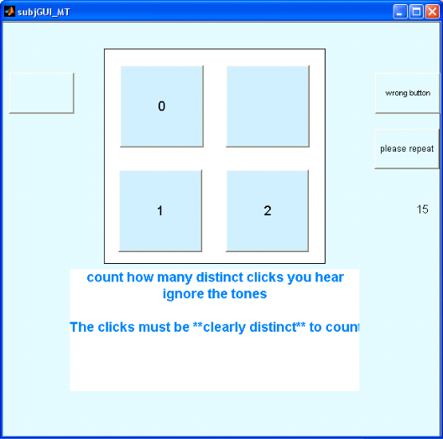 B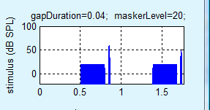
Figure 9 Forward masking paradigm. A: subject GUI for the cued condition. B: Cue and target; the target is the trailing tone pip in the second sound. The target tone pip is less intense than the target in the cue.

Paradigms
Multithreshold allows for many measurement paradigms. The pop-up menu at the top of the paradigm box in the central panel allows the experimenter to initiate an experiment quickly by choosing pre-set stimulus parameters and control sequences. When a paradigm is selected, all of the settable values on the experimenter GUI are changed to suit the new paradigm. After selecting the paradigm, the experimenter is then free to fine-tune the stimulus parameters to suits his particular needs.

Stimulus configuration
Although not essential, it is worth spending a few moments now to master the basic underlying model used by the software to generate the stimulus. Each foreground stimulus is composed of four items presented in sequence.
Cue masker
Cue tone
Test masker
Test tone (target)

In some paradigms, individual items are omitted. For example absolute threshold measurements omit the masking stimulus. Also uncued stimuli omit the cue interval. This arrangement allows for a consistent terminology across many paradigms.
All stimuli contain a target and the subject’s task is normally to say whether or not he hears it. Sometimes he may be asked to say whether it is uncomfortable or whether it has a higher frequency than the masker. Nevertheless, the focus of the decision is always the target. For pure tone stimuli, its attributes are frequency (Hz), duration (s) and level (dB SPL). For noise stimuli only duration and level are relevant.
In some paradigms a masker is also present. For pure-tone maskers its attributes are frequency (Hz), duration (s) and level (dB SPL). For noise maskers, only duration and level are relevant. (bandpass noise is not currently implemented).
When a masker is present, the duration of the gap between the offset of the masker and the onset of the target is important. This gap can be either positive (target trails the masker) or negative (the target onset precedes the masker offset).
In a cued paradigm, the masker plus target combination is played twice. The two stimuli are always identical except in one respect specified by the cueTarget difference. This difference is applied to the within runs variable which differs from paradigm to paradigm. It is applied in such a way as to make the subject’s task easier in the cue interval. For example, when measuring pure-tone threshold, the difference applies to the level of the target so that it is easier to hear during the cue interval. The same is true in the forward masking paradigm where the masker is less intense in order to make detection of the target easier.

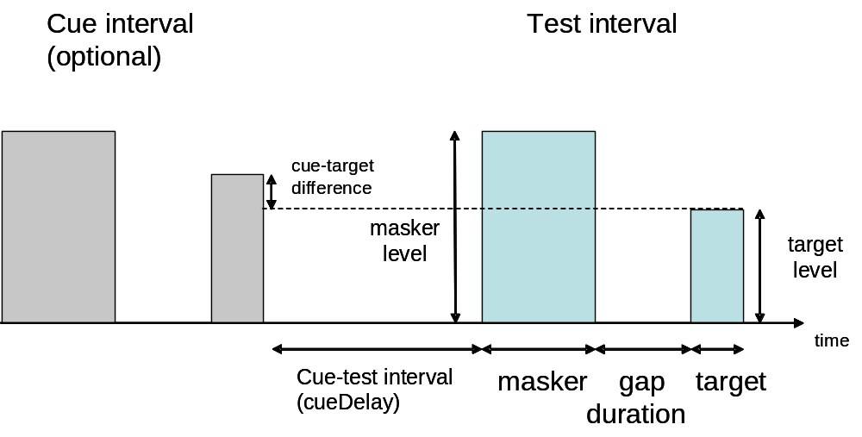
Figure 10 Generalised stimulus paradigm used by MultiThreshold. Specific paradigms may omit some elements but the terminology remains the same throughout.

Training
This paradigm is intended as an introduction to the testing situation. It is configured as a pure tone threshold estimation using the cued single-interval up/down method of assessment. The frequency is set to 1000 Hz and the duration is set to 0.1 s. The subject’s task is to count the number of beeps heard’. The number of trials after the first reversal is set to 10. Only one run is requested. The assumption is that the experimenter will want to give the subject feedback and further advice after each training run.

Absolute threshold (‘abs Threshold’)
This assesses the pure-tone threshold at a number of different frequencies using cued tones. The target duration is 0.5 s. However, target duration is set as the second between-runs variable so that more than one duration can be specified.

8 ms absolute threshold (‘abs threshold_8’)
The 8-ms absolute threshold is often required before measuring iso-forward masking curves or temporal masking curves. These paradigms require an 8 ms probe to be set at a fixed level above its threshold. No between runs variables are set. This is a single run paradigm.

TEN test (‘TENtest’)
Pure-tone thresholds for 5-ms tones at a range of frequencies are measured against a background of threshold equalized noise (TEN). The level of the noise can be set in the box alongside the background type pupup menu.

Threshold duration function (‘thresholdDuration’)
The pure-tone threshold for a 1000 Hz tone is measured at seven different tone durations between 8 and 512 ms.

Discomfort
The level at which a 500-ms pure tone becomes uncomfortable is measured using the the subject GUI shown in Fig. 11. A range of different frequencies is specified as the between-runs variable. The subject’s task is to rate each stimulus as comfortable, loud or uncomfortable. Only a single tone is presented on each trial (no cue). After each judgment, the level is raised by 3 dB. When the subject declares the tone to be uncomfortable the trial is stopped and the next trial is initiated.
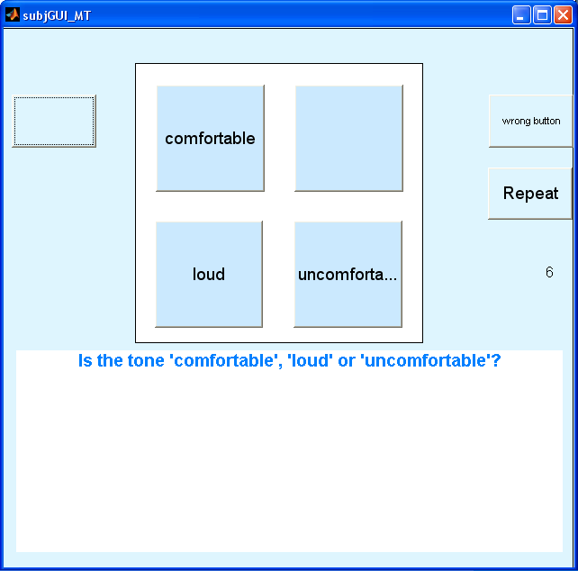
Figure 11 subject GUI for the 'discomfort' paradigm

Forward masking.
The stimulus in the forward masking paradigm is a masker followed by a target tone. The subject’s task is to indicate whether or not he hears the target tone. The within-runs variable is the target tone level and this is changed between trials. For more information concerning the design of masking stimuli, see above.

Temporal masking curve (TMC)
In this forward masking paradigm, the audibility of the trailing target is manipulated by changing the level of the masker. The final threshold value is the level of the masker just necessary to mask the fixed-level target.
Note that the targetLevel box is empty. The level of the target must be set by the experimenter prior to beginning the run. Typically, the target is set to be 10 dB above the subject’s 8-ms target threshold. The threshold for the 8-ms target should be obtained earlier by first running the ‘abs threshold_8’ paradigm (see above).
The maskerRelativeFrequency has been set as the second between-runs variable. This allows the experiment to choose more than one masker frequency. It is traditional to measure at least one frequency that is substantially lower than the target frequency. This is called the ‘off-BF linear reference’.

Temporal masking curve with two target levels (TMC – ELP)
This is the same as the TMC paradigm described above. However, on this occasion, two different target levels are specified, 6 dB apart. In a linear system, the masker levels required to mask the two probes should differ by 6 dB. If the difference is much greater, this is a sign of compression.

Iso forward-masking contours
This paradigm measures the masker level that is just necessary to mask the probe. It is the masker level that is adjusted between trials. Each run uses a different masker frequency. The expectation in a normal listener is that the required masker level will be greater, the bigger the difference in frequency between the target and the probe. This gives rise to a V-shaped contour.
The default configuration is for an 8-ms tone at 1000 Hz. The (relative) masker frequencies vary between 0.5 and 1.3 times the target frequency. The level of the 8-ms target tone must be set to 10 dB above its threshold. The threshold for the 8-ms target can be obtained by first running the ‘abs threshold_8’ paradigm (see above). Figure 12 shows examples of IFMCs for different target frequencies for a normal subject and for a subject with impaired hearing.
The gap duration is set to 0.01s because the gap is wide enough to avoid confusion between the masker and the target while being short enough to give reasonably low masker levels. This latter is important because the high target thresholds associated with hearing impairment often mean that the masker levels need to be unacceptably high if a long gap is used.
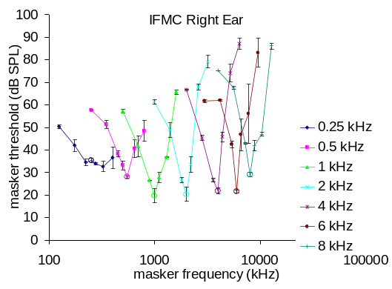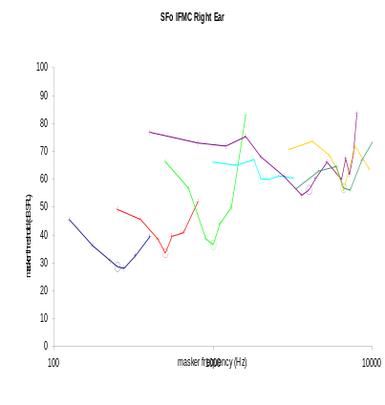
Figure 12. IFMC A: young, male, normal subject measured using MultiThreshold.

Growth of masking (GOM)
This paradigm measures the masker level just sufficient to mask targets at a number of different target levels. The maskerRelativeFrequency is set as a second between-runs variable as it is traditional to measure the function for a second masker frequency one octave below the target frequency.

Overshoot
This paradigm measures the threshold of a target when presented simultaneously with a masking tone. The target is tested twice; first when the target begins immediately after the onset of the masker and, second, when the target is presented midway through the masker. Thresholds for the target are normally higher when the target is presented at the beginning of the masker. This is also known as the ‘temporal effect’.
Notice that the gapDurations are negative. This is because the gap specifies the time between the end of the masker and the beginning of the target. If the target precedes the end of the masker, this implies a negative gap.

Gap detection
In this paradigm the gap between two identical 200-ms noise bursts is varied to find the minimum detectable gap. In the cued condition, subjects are asked to count how many stimuli contain a gap (1 or 2). The within runs variable is the gapDuration.
Multithreshold builds the stimulus as follows. The ‘masker’ is the sound before the gap and the ‘target’ is the sound after the gap. For this stimulus, the term masker and target do not refer to the subject’s task. The task is to detect the gap between the masker and the target.
Note that the ramp duration is set to only 1 ms for this test. Also, the cueTestDifference is used as a multiplier so that a cueTestDifference of 1.1 indicates a 10% difference in the gap duration between the cue and the test stimulus.

Frequency discrimination
In this task, the subject hears a stimulus consisting of two successive tones and his task is to judge whether the tones have the same pitch or are different. In the cued condition he hears two pairs of tones and counts the number of pairs with different pitches.
MultiThreshold builds the stimulus as follows. The ‘masker’ is the tone before the gap and the ‘target’ is the tone after the gap. For this stimulus, the term masker and target do not refer to the subject’s task. The task is to detect a frequency difference between the masker and the target.
The cueTestDifference is used as a multiplier so that a cueTestDifference of 1.1 indicates a 10% difference in the frequency difference between the cue and the test stimulus.

The use of relative frequency reduces the number of expensive mistakes caused by inserting a masker frequency different from the probe frequency when this is not intended. It also is a powerful feature allowing flexibility in the IFMC paradigm used for ‘tuning curves’.
IFMCs should not be confused with BM tuning curves or psychophysical tuning curves (PTCs). They are closely related in normal listeners but it is important to retain a distinction. A PTC is normally a measure of the tuning of a single location along the basilar membrane. When PTCs are measured, efforts are made to prevent ‘off-frequency listening’. IFMCs will allow off-frequency listening and this is important when tracing dead regions. An IFMC simply measures the ability of tone at one frequency to mask tones at another. While BM tuning contributes to the IFMC contour, other factors contribute too. For example outer and middle ear pre-emphasis helps shape frequency selectivity. IFMCs measure the totality of the patient’s frequency selectivity.

